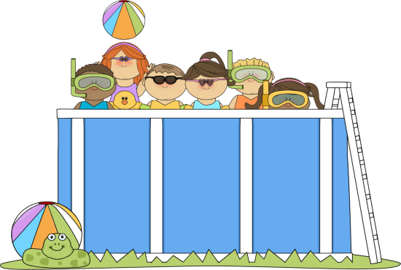
Here are fun and simple activities to do with the family. They will help you expose your child to appropriate vocabulary and concepts every day of the month. The activities require very little planning and can be easily completed in and around the home. Please take time to enjoy these fun activities with your child!

For additional information, please visit the Speech Therapy web site at www.brds.org under Elementary School-classrooms-Specialist
Sadie McFadden, Speech Therapist

Have Fun in the Sun

AUGUST
Sunday | Monday | Tuesday | Wednesday | Thursday | Friday | Saturday
Talk about the important dates in August (holidays, birthdays, etc.) | Go for a walk and describe the houses you see using words like tall, wide, square, and new. | Move fast and slow while making shadows. | Find rough and smooth things in a kitchen drawer. | Have watermelon for a snack. Count the seeds you find. | Tiptoe quietly across a room. Then stomp loudly across a room. | Find things in the yard that are round. Talk about which items roll.
Buy bananas and talk about their color and shape. Use the bananas to make a snack. | Practice hitting a softball with a bat. Count the number of hits. | Name all the vegetables you see in the store. | Color a picture on a paper plate. Hang the picture on a kitchen cupboard. | Try on the different hats in the house. Talk about how each hat looks and feels. | Find the widest and narrowest tree in your yard or neighborhood. | Kick a big ball around the yard. Talk about how the ball moves.
Count all the windows in the house. Talk about open versus closed windows. | Use streamers, stickers and balloons to decorate a bike or wagon. | Cut out different shapes from colored paper and make a collage. | Read a story about flowers. | Press flowers in a book. Let them dry, and then use them to create a picture. | Pick up objects in the yard and decide which are heavy and which are light. | Hold ribbons out in the wind and watch them move.
Look outside for machines that are used in construction. | Tape a leaf to paper and color around it. Remove the leaf and see the outline. | Spread jam on bread for a snack. Talk about how jam is made. | Pick up objects with your toes. Talk about how toes are different from fingers. | Wash a bicycle. Talk about the different parts of the bicycle. | Talk about words that rhyme with hot. | Take turns describing stuffed animals found around the house.
Make funny faces in a mirror. Then draw pictures of funny faces. | Dance and sing along to music. | Strung paper clips together to make a necklace. Count the paper clips. | Talk about all the things needed for a camping trip. | Find different containers in the house (e.g., jar, egg carton, box, and bottle) and talk about their shapes. | Walk around the house or neighborhood looking for pink flowers. Draw a picture of your favorite flower. | Look back at this month’s calendar. Talk about the important things that happened.

