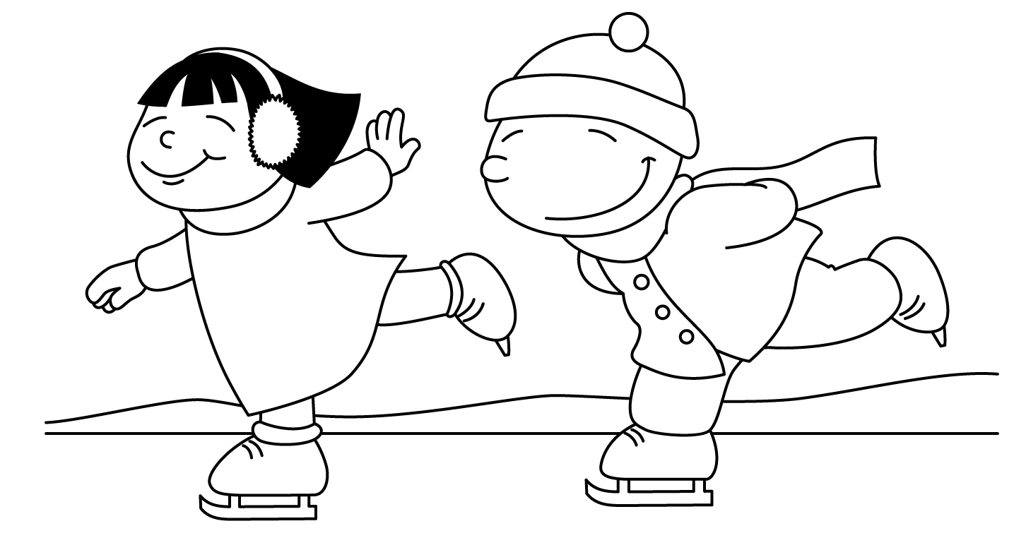
Holidays are past, nights are longer, and it’s cold outside. Here are fun and simple activities to do with the family. They will help you expose your child to appropriate vocabulary and concepts every day of the month. The activities require very little planning and can be easily completed in and around the home. Please take time to enjoy these fun activities with your child!

For additional information, please visit the Speech Therapy web site at www.brds.org under Elementary School-classrooms-Specialist Sadie McFadden, Speech Therapist

Snow days
are here!

JANUARY
Sunday | Monday | Tuesday | Wednesday | Thursday | Friday | Saturday
Talk about the important dates in January (holidays, birthdays, etc.) | Make footprints in the snow. Talk about their shapes and sizes. | Talk about what you would do outdoors in the snow. | Make a collage with glue and construction paper with pictures from a magazine. | Use a marker to draw a face on an old sock and use it as a puppet. | Use food coloring to turn potatoes green. Talk about how potatoes grow. | Make the bed. Talk about how the pillows and mattress are rectangles.
Fold clothes together. Separate the items into piles. | Sing an action song such as The Itsy-Bitsy Spider. | Draw a picture and use words like tall, short, fat, and skinny when drawing. | Name baby animals (puppy, kitten, lamb,  etc.) Describe what they look like. | Play Charades using actions (hop, skip, roll, jump, etc.). Talk about what you’re doing. | Choose an animal. Talk about what it looks like, eats, where it lives. | Blow bubbles and talk about how the bubbles move.
Find a short poem and recite it often. | Match a pile of mittens or socks. | Read a winter story. | Talk about the different jobs people have. | Make popcorn and talk about how popcorn pops. | Do an activity outdoors and talk about what you are doing. | Make a picnic lunch to eat in the living room or in the backyard.
Act out a favorite story. | Cut out the initials of your child’s name from a large piece of paper. | Roll a ball into a pail that has been laid on its side. Talk about how the ball rolls. | Set up an obstacle course. Talk about under, over, inside, outside, between. | Talk about things in a room that are round. | Name an adjective, such as shiny, and then name things the word describes (ex. mirror, spoon) | Draw flowers on paper and tape them all over the room.
Place a carnation in food coloring and water. Watch the flower change color. | Play Store with the canned goods in your kitchen. | Make a poster of smiley faces to put on the refrigerator. Show the poster to quests. | Draw a thermometer and describe what happens when the weather is very cold or hot. | Draw how the weather looks outside. Use words to describe it, such as cold, windy, and sunny. | Look at a photograph of family members and name everyone. Talk about what is happening. | Look back at this month’s calendar. Talk about the important things that happened.

