May flowers are blooming
Here are fun and simple activities to do with the family. They will help you expose your child to appropriate vocabulary and concepts every day of the month. The activities require very little planning and can be easily completed in and around the home. Please take time to enjoy these fun activities with your child!

For additional information, please visit the Speech Therapy web site at www.brds.org under Elementary School-classrooms-Specialist
Sadie McFadden,
Speech Therapist

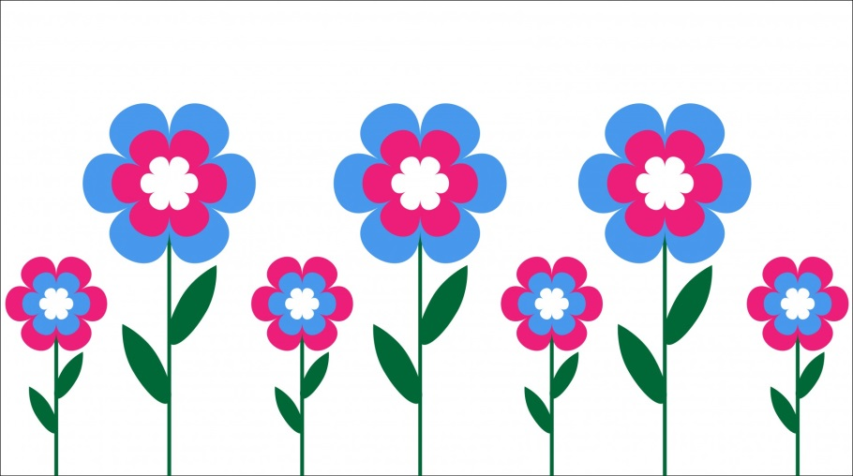

MAY
Sunday | Monday | Tuesday | Wednesday | Thursday | Friday | Saturday
Talk about the important dates in May (holidays, birthdays, etc.) | Visit the library and find books about fruit. Talk about your favorite fruits. | Go for a walk and count cars in people’s driveways. | Make a map of your house and label each room. | Make a card for someone special. | Watch a cartoon and talk about what happened. | Go through a kitchen cupboard and sort the food by type (e.g., fruit, vegetables, pasta, cereal).
Read a story and have your child turn the pages. | Sort the laundry and talk about light and dark colors. | Make cookies and talk about the colors of the different ingredients. | Talk about the things in the kitchen that are shaped like a square. | Eat pizza and talk about the different shapes on the pizza (e.g., round pepperoni, triangle or square slices. | Take a walk and talk about the plants you see. | Go to the store and buy vegetables. Talk about your favorite vegetables.
Sing a favorite song. Make up actions to go with the words. | Form playdough or clay into shapes (e.g., balls, cones, boxes). | Talk about things that make people sad. | Go for a “listening walk” and talk about the different sounds you hear. | Find several boxes and sort them by size. | Find bugs outside and talk about what they look like. | Have another child over for a picnic lunch.
Talk about what you did yesterday. | Taste sugar and salt. Talk about foods that are sweet and foods that are salty. | Look through a jewelry box and describe the various items (e.g., shiny, dull, old, bright) | Fill a jar with beans and use it as a shaker. Play music while shaking it. | Make chocolate milk using milk and chocolate syrup. Talk about each step. | Talk about the weather and draw a picture of a rainy day. | Pick some flowers and weeds. Arrange the bouquet in a vase.
Plant a flower outside. Talk about how to care for the flower. | Go outside and look at the trees. Talk about the buds or leaves you see. | Measure you height and your child’s. Talk about the difference. | Go for a walk and count all the trucks you see. | Hop over the lines in the sidewalk while counting each one. | Talk about the people who work in a hospital (e.g., nurses, doctors, custodians). | Look back at this month’s calendar. Talk about the important things that happened.

