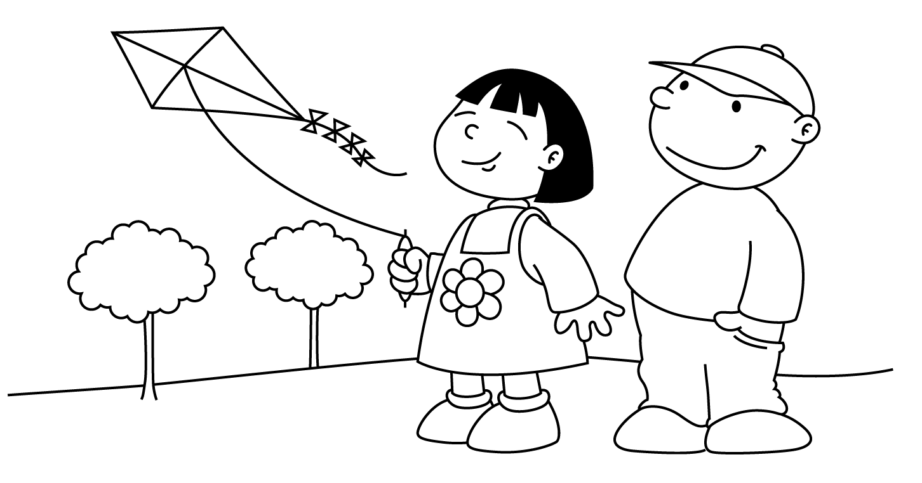
Let’s fly a kite!

It’s the windy days of March and a great time to be outdoors! Here are fun and simple activities to do with the family. They will help you expose your child to vocabulary and concepts every day of the month. The activities require very little planning and can be easily completed in and around the home. Please take time to enjoy these fun activities with your child!

For additional information, please visit the Speech Therapy web site at www.brds.org under Elementary School-classrooms-Specialist Sadie McFadden, Speech Therapist

MARCH
Sunday | Monday | Tuesday | Wednesday | Thursday | Friday | Saturday
Talk about the important dates in March (holidays, birthdays, etc.) | Talk about all the green items in a room. | Watch a favorite TV show and talk about it. | Sweep the kitchen floor. Use words like broom, dustpan, and dirt. | Make a cake and frost it with a special color of frosting. | Read a story, such as Little Red Riding Hood. Draw a picture of the main character. | Count all the clocks in the house.
Talk about bugs you see outside where they live. | Find items in the basement or garage that are shaped like a triangle. | Name animals and make the sounds they a make. | Make a telephone call. | Organize the toy box. | Play a board game and talk about the rules | Trace hands and feet on paper. Decorate them with craft supplies.
Cut out pictures of fruit from a magazine and glue them onto a large piece of paper. | Hop down the hall or across the room. Count the number of hops. | Use a flashlight to search in a closet. Talk about what you find. | Color a picture and talk about the colors. | Look at a brush and comb. Talk about how they are the same and how they are different. | Touch things in the room and describe how they feel. | Fill glasses with different levels of water and listen to the sounds as you tap the glasses with a spoon.
Cut out pink and blue things from a magazine. Make a collage. | Sing along with a favorite song. | Look at a store advertisement and find different numbers. | Make a milkshake and talk about the different ingredients. | Visit the airport and watch the planes take off and land. | Go for a walk and look for white cars. | Make a spaceship from a cardboard box. Tell a story about space travel.
Pretend to be different storybook characters. Act like the characters. | Draw funny faces on a steamy mirror. | Dance to music and talk about you actions. | Find the biggest and smallest stuffed animal in the house. | Look at a photograph and draw a picture of it. | Listen to the noises outside. Try to guess what they might be. | Look back at this month’s calendar. Talk about the important things that happened.

