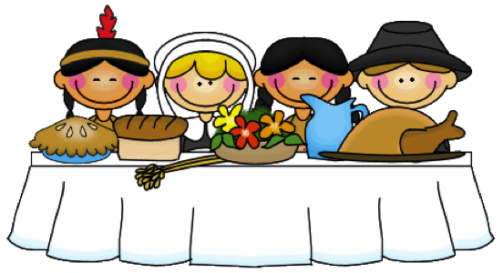
Here are fun and simple activities to do with the family. They will help you expose your child to appropriate vocabulary and concepts every day of the month. The activities require very little planning and can be easily completed in and around the home. Please take time to enjoy these fun activities with your child!

For additional information, please visit the Speech Therapy web site at www.brds.org under Elementary School-classrooms-Specialist Sadie McFadden, Speech Therapist

Happy Thanksgiving

NOVEMBER
Sunday | Monday | Tuesday | Wednesday | Thursday | Friday | Saturday
Talk about the important dates in November (holidays, birthdays, etc.) | Read a story about friendship. Talk about friends. | Talk about things that are cold. | Take turns hiding and finding a small object. Hide it in, on, and under bigger objects. | Line up cans by height from tallest to shortest. | Talk about animals that make good house pets. | Turn on the lights in the house, and then turn them off. Talk about on and off.
Name clothes people wear to stay warm (e.g., sweater, coat, gloves, boots). | Talk about loud noises and quiet noises. | Count the toy cars and dolls in a toy box. Make a pattern (e.g., doll, car, doll, car). | Take a walk. Walk in front of, behind, and then beside each other. | Talk about arms. Find arms on bodies and arms on furniture. | Name things that can be opened (e.g., door, envelope, box of cereal). | Look at items in a kitchen drawer and talk about their uses.
Put an object in a box. Shake the box and have your child guess what’s inside. | Find a chair with short legs and a chair with long legs. | Trace an outline of your hand. Talk about what fingers can do. | Put objects above, below, and through other objects. | Put groceries away. Talk about the items and where they go. | Sort colorful candies into piles based on colors. | Find things that are scratchy and things that are furry.
Sort playing cards based on their colors. | Float marshmallows in hot chocolate and watch them melt. | Wear all blue clothes and look for blue items in the house. | Look at pictures in a favorite book and tell the story. | Close your eyes and smell different foods. Try to guess foods based on their scents. | Glue cotton balls onto paper to make snow scene. Talk about how snow feels. | Talk about the body parts we use for smelling, seeing, feeling, hearing.
Talk about objects that go together (e.g., shoes/socks, salt/pepper, fork/spoon, brush/comb). | Go outside and count all the trees you see. | Talk about animals that live in the forest and animals that live in the jungle. | Blow a piece of tissue across the table and talk about how it moves. | Perform a finger play or song about winter. | Talk about names of different relatives (e.g., aunt, uncle, cousin). | Look back at this month’s calendar. Talk about the important things that happened.

