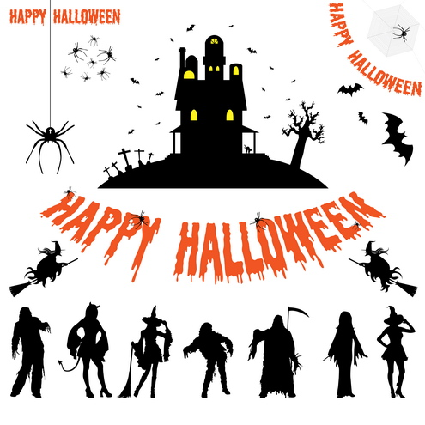
Here are fun and simple activities to do with the family. They will help you expose your child to appropriate vocabulary and concepts every day of the month. The activities require very little planning and can be easily completed in and around the home. Please take time to enjoy these fun activities with your child!

For additional information, please visit the Speech Therapy web site at www.brds.org under Elementary School-classrooms-Specialist
Sadie McFadden, Speech Therapist

OCTOBER
Sunday | Monday | Tuesday | Wednesday | Thursday | Friday | Saturday
Talk about the important dates in October (holidays, birthdays, etc.) | Talk about yesterday’s and today’s weather | Clean out the toy box and sort the toys. | Touch and name three body parts that come in pairs. | Wash dolls and toy cars in the bathtub. Talk about which are wet and which are dry. | Make different letter shapes with your body by bending and stretching. | Go outside and count all the things you can find that grow.
Walk around outside and make a big pile of leaves and a little pile of leaves. | Find soft things in the house. Talk about why they’re soft. | Go outside and find a stick that is crooked and a stick that is straight. | Yawn really big. Talk about feeling sleepy. | Find orange things in the house. | Lie on your back and move your legs like you’re riding a bicycle. Move fast then slow. | Name animals that live on a farm.
Talk about clothes people might wear in the fall (e.g., sweater, hat, jacket). | Look for things in the kitchen that are empty and things that are full. | Build tall and short towers with toy blocks. | Make a picture by gluing leaves onto a piece of paper. | Read a book about fall. Talk about what happens in the fall. | Make cookies shaped like triangles and circles. | Use paper towels or fabric strips to make clothes for small dolls or action figures.
Line up several chairs to make a pretend bus. | Fill a squirt bottle with water and spray it on the sidewalk. Watch if the water dries fast or slow. | Stack books and talk about thick books and thin books. | Find Halloween on the calendar. Count the number of days until Halloween. | Make a mask out of a paper bag. Draw a picture of the mask. | Decorate a shoebox to use as a house or a bed for a doll or stuffed animal. | Look for squirrels outside. Count how many you find.
Talk about different Halloween costumes. | Read a Halloween story and have your child tell about their favorite part. | Carve a pumpkin to make a jack-o’-lantern. | Bake some pumpkin seeds and eat them. | Go outside at night and look at the stars. Talk about if there are many stars of just a few. | Sort different candies based on the size, shape, or color. | Look back at this month’s calendar. Talk about the important things that happened.

