Welcome
to
School
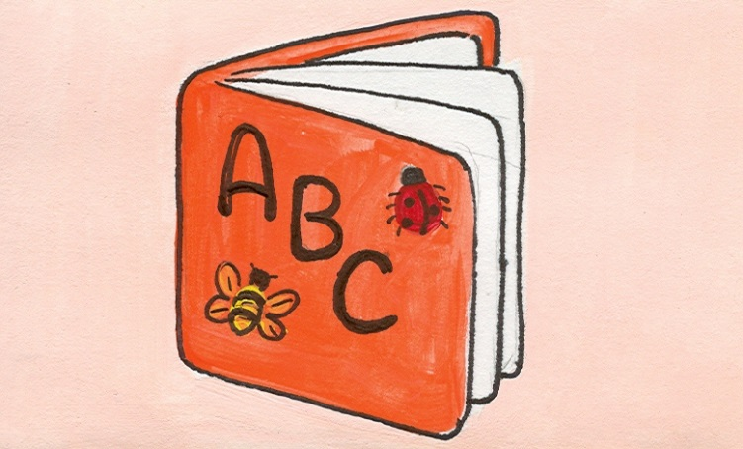
Here are fun and simple activities to do with the family. They will help you expose your child to appropriate vocabulary and concepts every day of the month. The activities require very little planning and can be easily completed in and around the home. Please take time to enjoy these fun activities with your child!

For additional information, please visit the Speech Therapy web site at www.brds.org under Elementary School-classrooms-Specialist Sadie McFadden, Speech Therapist

SEPTEMBER
Sunday | Monday | Tuesday | Wednesday | Thursday | Friday | Saturday
Talk about the important dates in September (holidays, birthdays, etc.) | Do exercises and talk about the different movements you use. | Find light and dark green plants and trees in the house and yard. | Talk about the names of the stuffed animals in the house. | Talk about and practice a fire escape route in your house. | Use paint to paint a rainbow. Label the different colors. | Make cookies with faces on them. Talk about the parts of the face.
Make a kite from paper. Fly it in the wind and talk about how it moves. | Learn a poem and recite it with actions. | Talk about tiny things you find in the house. | Look through photo albums and talk about what’s happening in the pictures. | Walk to a busy street and listen for traffic noises. Talk about being safe when near traffic. | Talk about the different shapes of clouds in the sky. | Make toast for breakfast. Cut the toast into different shapes (e.g., triangles, squares, circles).
Read a favorite story. Have your child help tell the parts of the story. | Go on a walk. Move fast and then move slowly. | Count the tables in the house. Find the biggest and the smallest table. | Have a picnic in the park or in the backyard. Talk about the difference between inside and outside. | Tap wooden, plastic, and metal spoons against a tin can. Talk about the different sounds. | Play catch with a small ball. Throw the ball high and roll it low. | Build a tower from empty boxes. Talk about big and small boxes.
Make lemonade or Kool-Aid. Talk about each step. | Collect bugs and put them in a jar with grass, sticks, and leaves. Describe each bug. | Toss wadded up socks into a laundry basket. Count the number of times the socks go in. | Help your child make a phone call to invite a friend over to play. | Make potato prints. Cut shapes on the bottom half of a potato, dip it in food coloring, and press it onto paper. | Have your child look through a grocery ad and cut out favorite foods. Glue the pictures onto a paper plate. | Count to 5 or 10 using fingers or toes.
Help your child send a postcard to a relative. | Talk about at least two things you did yesterday. | Walk down the stairs, and then crawl up the stairs. | Listen to music and do a funny dance. | Talk about all the tings needed to wrap a present. Wrap a box in newspaper. | Look for pictures of horsed in storybooks. | Look back at this month’s calendar. Talk about the important things that happened.

